**Multi Step Enrolment flow:**

1)Create packet with demographics details 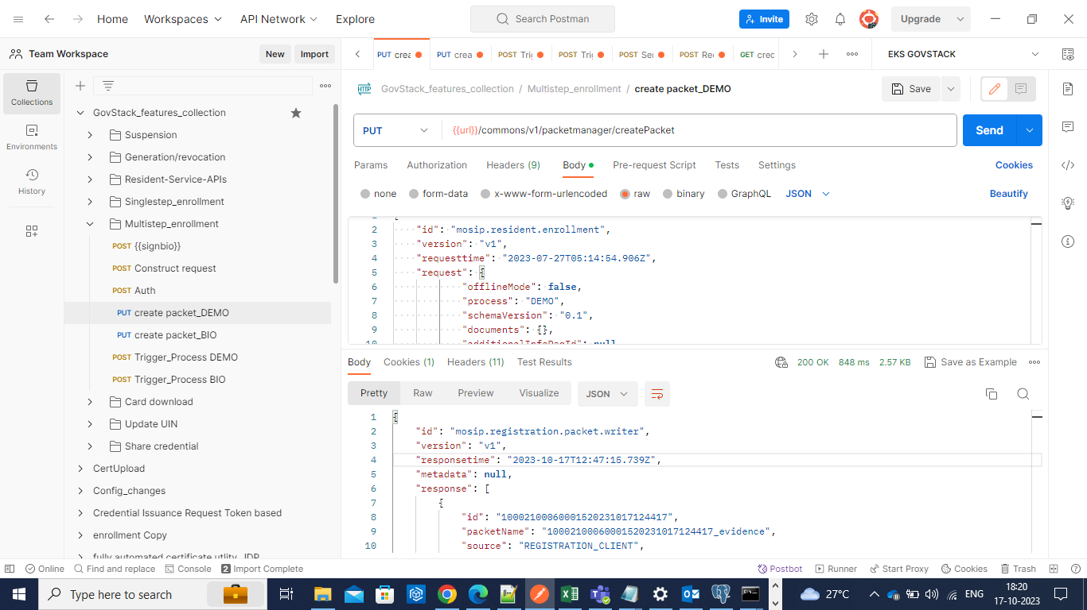

2) Create packet with biometric details.

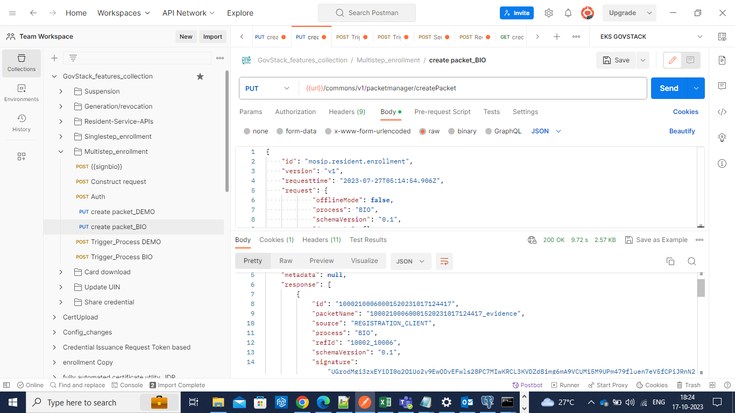

3)Upload demographic packet.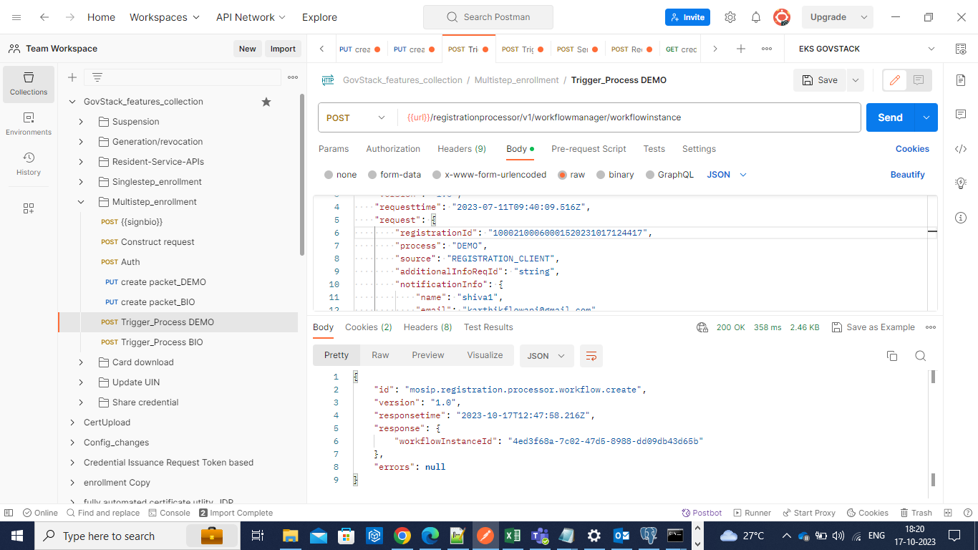

4) Upload biometric packet. 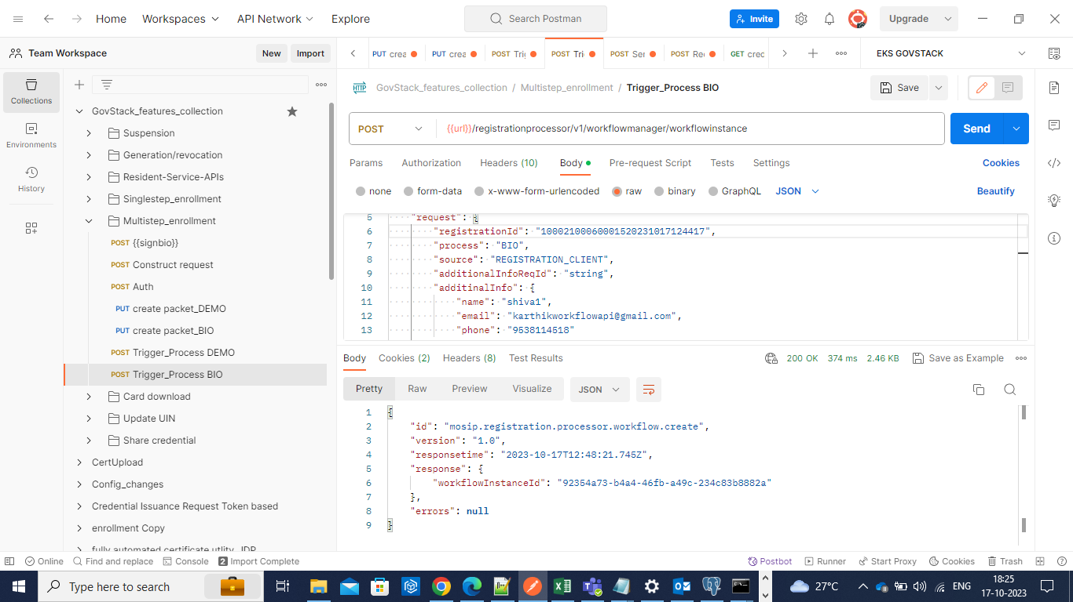

5)Notification for registration confirmation

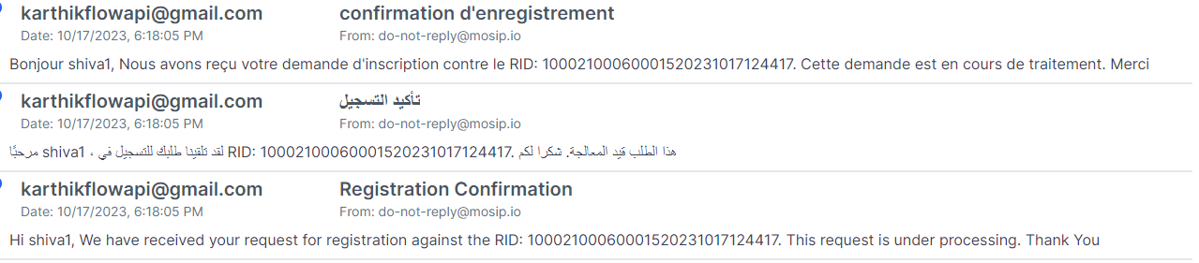

6)Notification for UIN generation.

